Renju lesson on May 16, 2002

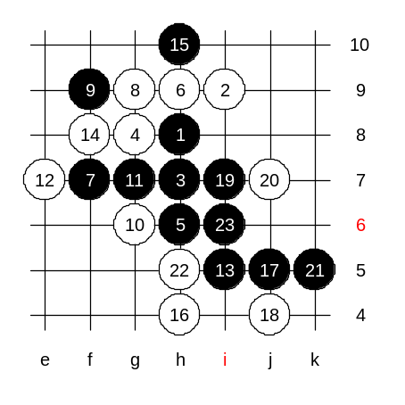
Hello everyone! Welcome to Online Renju Class. Here are the 15 moves we studied last week. I think there are only two 16th moves that are interesting for us - 16-h5 and 16-h4. Since we do not have much time, we will check 3 possible variants of this 16th move in quick speed and then go on. Please select the first defense? Please, if you are interested in knowing win somewhere, point out the white move you want to check about.

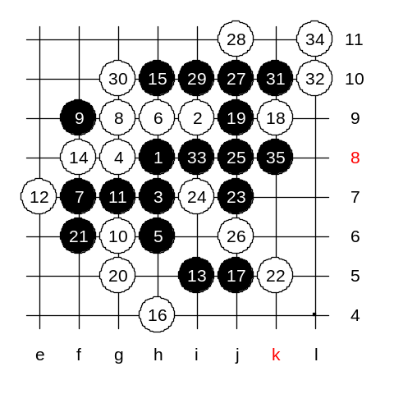

Ok, We play k9 first, seems to be the best defense.
And now where? Which 22nd move? We try k5.
Who is ready to prove win, say ME.
Good, thanks shadewawa for showing the win! :)

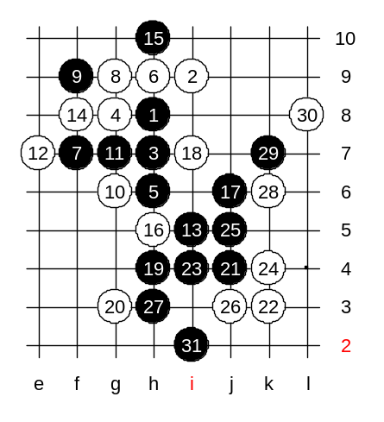

How about 16-h5? Any ideas for black?
Lets just try 18-i7 and prove win. Who wants to say ME?
Good luwenzhe, nice win!

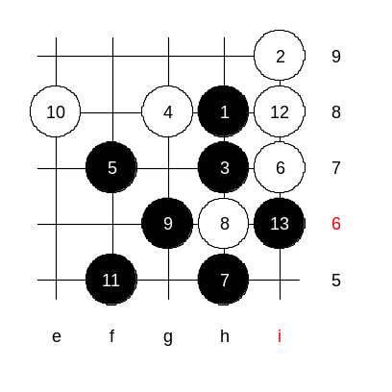
We have learned two 5th moves. Both are winning ones. But we also noticed that the win is not so simple at all.
Human head is not a trash-can, therefore I introduce two other 5th moves that give easy win instead.
I prepared the sure win variants for this class. First, 5-f7. There are only a few blocks we need to care about. 6-i7, easy attack follows. Can white do anything now?
No.

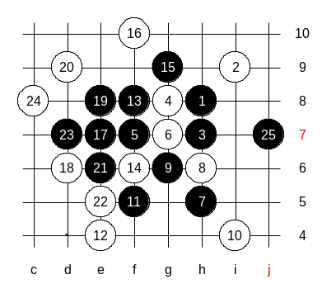
6-g7. Also easy. Can white do anything now? Who will show win now? Say ME.
Good job tunnet!! Nice win!

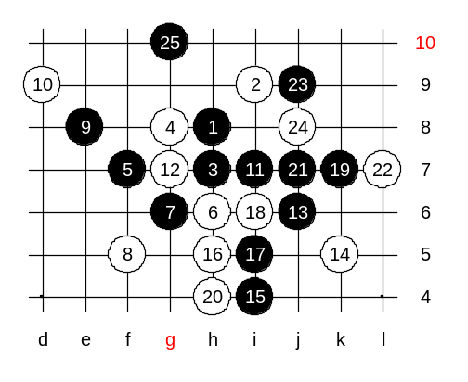
Move 6-h6, the 7-g6 follows. A logical and easy move. 8-g7 is impossible because it leads to previous variant, so only 8-f5 is worth to check. Easy, right?

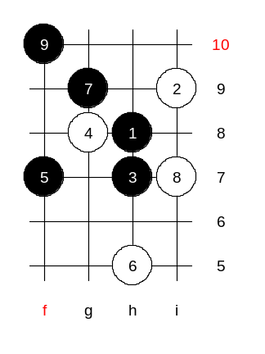

One more 6th move, 6-h5. Tunnet was watching when I prepared this variant last week. Tunnet, you remember my winning 7th move? Yes, g9. :) After the 9th move white is dead. Do you agree?

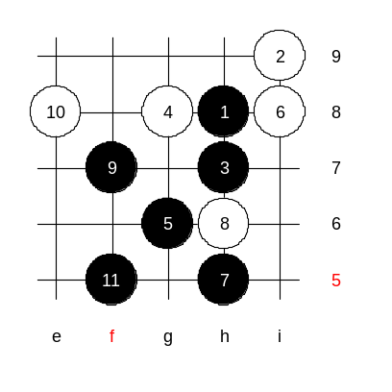
Do you agree that this 5-f7 is easier black win than the previous two 5th move we learned? Move 5-f7 is not in any of renju books. It is my example for you how renju may have many more choices but just traditional. Well, since I already went out of theory, I also prepared another winning 5th move, as easy as 5-f7.
Here, 5-g6.
6-h6 loses fast because of 7-f7, ok? Becomes the variant we just learned.
Similar idea here. :)

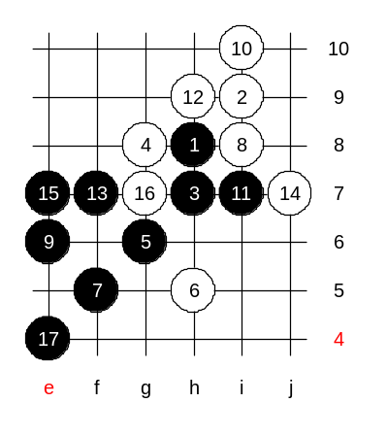
6-h5 - This is the last 6th move we need to study about.
So many winning plans here. Who wants to suggest first? Please say ME if you are ready to introduce your idea. :) Here are soo many ways to win. Come on and be active. :)
How about this 9th move? If white cannot win then black wins right away, right? So we focus on white activity only. Where? Black has control everywhere, is it correct?

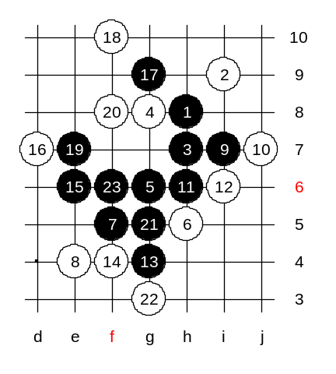
How about the lower 8th move? What to do next?
What to do after 9-i7? We just try one example 10 here. Who wants to show win??
Good, tunnet, thank you! :)

We have just proved two winning 5th moves in short time. Yes, f7 and g6 - both easy black win. Besides those two 5th moves, there are others. Traditional Japanese theory suggests 5-h6 with so complicated attack. I do not know why 5-f7 and g6 were ignored. I think I can add the 5-f7 and 5-g6 to my book as an additional idea. Then people can decide what to use.
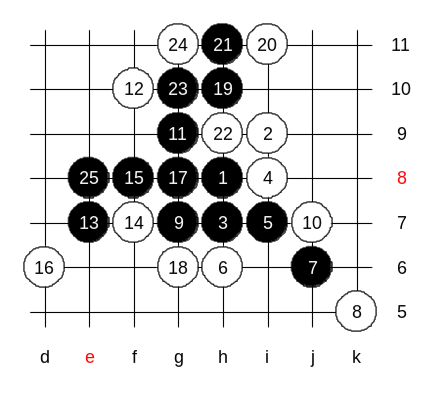

Next 4th move, where? :))
Ok, we check 4-i8.
5- i7. Who wants to show VCT? Good good, tunnet!

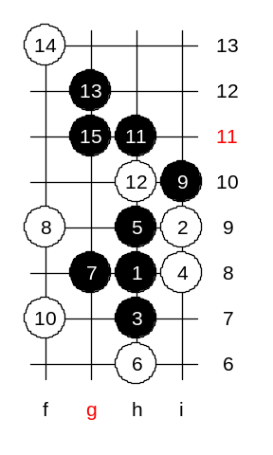

How about the second 5th move? Who has an idea?
Yes, move 5-h9 turns into i6 opening, and we have proved win there already. Therefore we do not need to repeat it now. Anyone can just go and review old lessons. :)

Besides those two 5th moves, there are some other winning 5th moves as well. Some even easier than 5-h9. Well. we have to end now. The time is over. We will meet again next week! Now, the credits. :))

